Practical 2: GPIO – Light the LED (with and without Button)
- Blink LED using Python (Raspberry Pi) or C++ (Arduino)
- Add a push button to toggle LED ON/OFF

Light an LED (without Button)
Wiring:
- Connect the LED’s anode (+) to a digital pin (e.g., pin 13)
- Connect the LED’s cathode (-) to a resistor (220Ω–330Ω) → GND
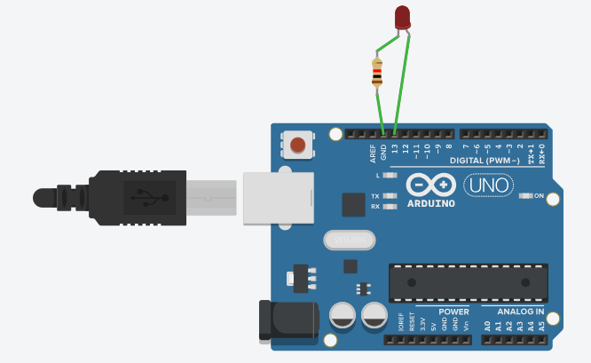
Code:
int ledPin = 13; // Pin connected to LED
void setup() {
pinMode(ledPin, OUTPUT); // Set LED pin as output
}
void loop() {
digitalWrite(ledPin, HIGH); // Turn LED on
// LED stays ON permanently
}
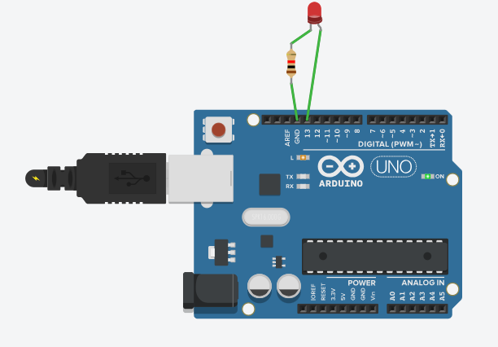

Blink LED
Code:
int ledPin = 13; // Pin connected to LED

void setup() {
pinMode(ledPin, OUTPUT);
}

void loop() {
digitalWrite(ledPin, HIGH); // Turn LED on
delay(500); // Wait 500ms
digitalWrite(ledPin, LOW); // Turn LED off
delay(500); // Wait 500ms
}
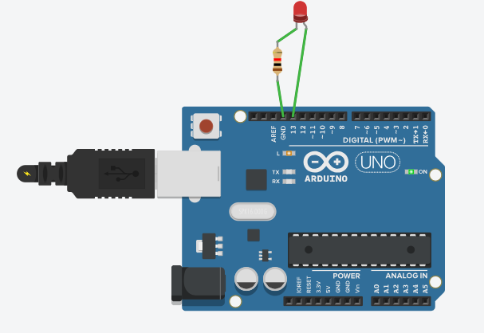
This will blink the LED every 1 second (0.5s ON + 0.5s OFF).

Toggle LED with Push Button
Wiring:
- LED: Same as before
- Push button:
  - One leg → digital pin (e.g., pin 2)
  - Other leg → GND
  - Use internal pull-up to simplify wiring
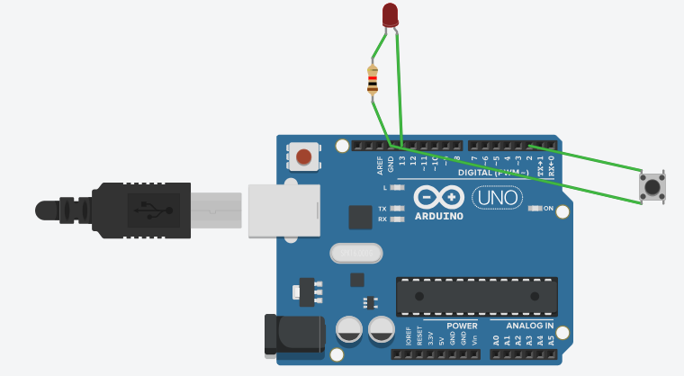

Code:
int ledPin = 13;
int buttonPin = 2;

bool ledState = false; // Track LED state
bool lastButtonState = HIGH;

void setup() {
pinMode(ledPin, OUTPUT);
pinMode(buttonPin, INPUT_PULLUP); // Enable internal pull-up resistor
}

void loop() {
bool buttonState = digitalRead(buttonPin);

// Check for button press (transition from HIGH to LOW)
if (lastButtonState == HIGH && buttonState == LOW) {
ledState = !ledState; // Toggle LED state
digitalWrite(ledPin, ledState); // Apply new state
delay(50); // Simple debounce
}
lastButtonState = buttonState;
}
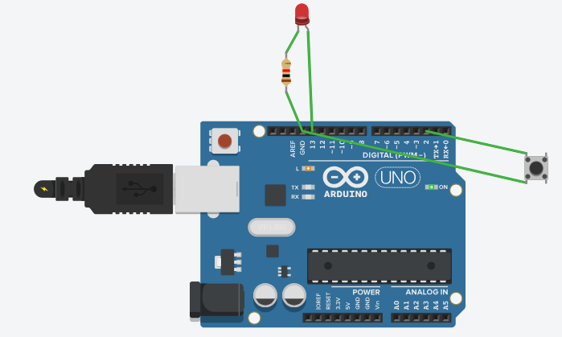
LED will blink when you click on  button.

